[Finance and economics](https://www.economist.com/finance-and-economics/) | Free exchange

Do Amazon and Google lock out competition?

亚马逊和谷歌是否通过限制竞争来排挤竞争对手？

How to assess the trustbusters’ case

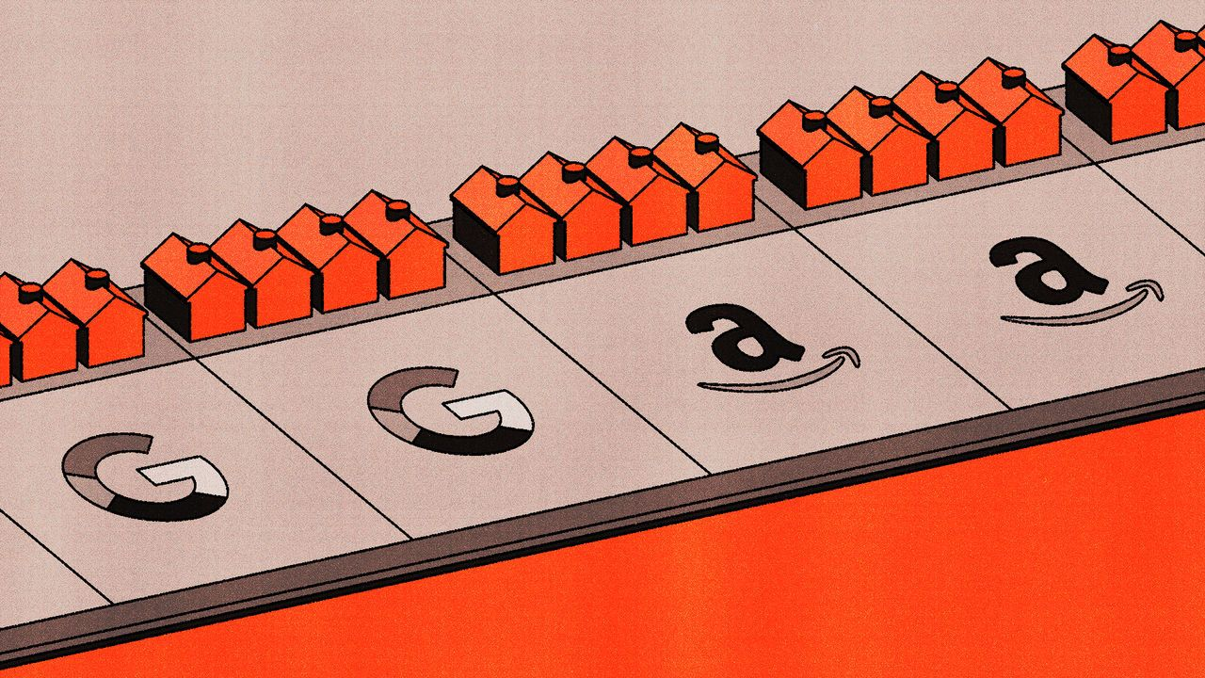

image: álvaro bernis

Oct 19th 2023

Anti-monopoly cases have been known to reshape corporate America. In 1984 at&t’s telephone network was found to have excluded competing firms. The company was controversially broken up in a move that ultimately led to a boom in innovation among its rivals. Meanwhile, a case against Microsoft in 1998 may have kept the door open for Google’s subsequent rise. Microsoft had bundled together its Internet Explorer browser with its Windows operating system, and made other browsers more difficult to install. Some business historians think the case, by stopping this practice, made life easier for new browsers. It may also have distracted Microsoft from developing its own search engine.

众所周知，反垄断案件重塑了美国企业界。 1984 年，AT&T 的电话网络被发现排除了竞争公司。该公司在一次倍受争议的分拆中被解散，此举最终促成了竞争对手的创新热潮。与此同时，1998 年针对微软的一桩案件可能为谷歌随后的崛起打开了大门。微软将其 Internet Explorer 浏览器与其 Windows 操作系统捆绑在一起，并使其他浏览器更难安装。一些商业历史学家认为，此案通过阻止这种做法，让新浏览器变得更轻松。它还可能使微软开发自己的搜索引擎的注意力被分散。

Today, two big cases could redefine the limits of monopolies in the internet age. On September 12th America’s Department of Justice (doj) began its court battle against Google over the firm’s deals to obtain default status on phones and browsers. On September 26th the Federal Trade Commission (ftc), chaired by Lina Khan, sued Amazon for allegedly penalising third-party sellers that offered lower prices on other sites, among other harmful practices. In both cases, the government thinks the tech giants are so dominant that their attempts to preserve market power are suspect. This raises a question: what counts as anticompetitive?

如今，两个重大案件可能会重新定义互联网时代垄断的界限。 9 月 12 日，美国司法部 (doj) 开始就谷歌与手机和浏览器厂商达成获得手机和浏览器默认定位的交易向法院提起诉讼。 9 月 26 日，由莉娜·汗 (Lina Khan) 担任主席的联邦贸易委员会 (FTC) 起诉亚马逊，指控其惩罚在其他网站上提供较低价格的第三方卖家以及其他有害做法。在这两种情况下，政府都认为科技巨头占据主导地位，以至于他们试图占据市场支配力的行为值得怀疑。这就提出了一个问题：什么算作反竞争？

Historically, practices that might be ignored for a startup have not been tolerated in a dominant firm. John Rockefeller’s Standard Oil was broken up in 1911, in part for striking deals with railroads that made it impossible for other oil firms to compete. Antitrust historians still debate the extent to which these deals were abusive—after all, Standard Oil benefited from economies of scale and bulk orders commonly receive discounts. But its size and bargaining power led to scrutiny. Before the firm’s break-up, it had cornered 90% of oil refineries. Microsoft’s bundling was found to be problematic because it had over 90% of the market for operating systems on personal computers. In both cases, the courts believed that dominant firms had made life too difficult for newcomers.

历史上，那些对于初创公司来说可能被忽视的做法，在一个主导型企业是不被容忍的。约翰·洛克菲勒的标准石油公司在1911年被拆分，部分原因是与铁路达成的交易，导致其他石油公司无法与之竞争。反垄断历史学家仍在就这些交易是否具有滥用行为进行辩论 - 毕竟，标准石油受益于规模经济，并且批量订单通常会获得折扣。但是其规模和议价能力引起了审查。在该公司被拆分之前，它已垄断了90%的炼油厂。微软的捆绑销售也被认为存在问题，因为它在个人电脑操作系统市场占有超过90%的份额。在这两种情况下，法院认为主导型公司给新进入者带来了过多的困难。

Today’s cases have echoes of those past. Start with Google. It pays more than $10bn to Apple and other companies to be the default search engine on their platforms. The doj argues this creates a barrier to entry for competitors. Because having lots of data lets a search engine show users more tailored advertisements, a dominant search engine has a larger expected ad revenue from an extra user. The twist is that if a smaller competitor happened to grow, it would be willing to pay more for additional users, thus bidding up how much Google would have to pay—and explaining why Google may be willing to pay large sums to prevent rivals from gaining a foothold. Yet it is easier to use a different search engine on an iPhone than it was to download a new browser on Windows. And Microsoft’s dominance in operating systems seems to have been greater than Google’s is in search. So the case is not airtight.

如今的案例与过去有所呼应。我们先从Google开始。它支付超过100亿美元给苹果和其他公司，以成为它们平台上的默认搜索引擎。美国司法部认为这样做会给竞争对手造成进入障碍。因为拥有大量数据可以让搜索引擎向用户展示更个性化的广告，一个主导型的搜索引擎会从额外用户中获得更多预期的广告收入。有趣的是，如果一个较小的竞争对手恰好实现增长，它愿意为获得额外用户支付更多，从而推高Google需要支付的费用，这解释了为什么Google愿意支付巨额资金来阻止竞争对手获得立足点。然而，在iPhone上使用不同的搜索引擎比在Windows上下载新浏览器要容易得多。而且微软在操作系统方面的主导地位似乎比Google在搜索领域的主导地位更大。因此，这个案件并非毋庸置疑。

The case against Amazon is stronger. Luigi Zingales of the University of Chicago thinks that if the alleged facts are found to hold, the ftc should win. Sellers complain that Amazon penalises them for offering cheaper prices on other platforms by downranking products or removing them from the “Buy Box”, which allows instant purchases. Antitrust scholars call practices that force sellers to behave similarly across platforms “most-favoured-nation” (mfn) treatment, and they have come under growing scrutiny. In the past Amazon has had explicit mfn contracts with sellers.

针对亚马逊的指证案件更为有力。芝加哥大学的卢易吉·津加莱斯认为，如果被指控的事实得到证实，美国联邦贸易委员会（FTC）应该能够获胜。卖家抱怨称，亚马逊会因为他们在其他平台上提供更低价格而对他们进行惩罚，通过降低他们的产品排名或从“购买框”中移除其产品来进行惩罚，该框用于允许用户立即购买。反垄断学者将强迫卖家在各个平台上采取类似行为的做法称为“最惠国”（MFN）待遇，并且这些做法受到越来越多的审查。过去，亚马逊曾与卖家签订明确的最惠国合同。

The problem, according to the ftc, is that Amazon has raised the cost of doing business on its platform. It charges sellers a fee for selling, one for using its logistics services and more for advertising. Sellers say that it is next to impossible to qualify for the Buy Box without paying for logistics, and that buying ads has become a must because search results are increasingly cluttered with them. Although the exact figures are redacted, regulators allege that Amazon now collects a larger share of sales on its marketplace as fees than it did a decade ago. In a competitive market, Amazon’s cost hikes and restrictions on pricing more cheaply elsewhere would cause sellers to leave the platform. And in fact, some large retailers, like Nike, have done so. But Amazon’s market share in e-commerce has grown (it currently stands at 40-50% in America), suggesting most sellers feel that the platform is too important to quit.

根据美国联邦贸易委员会（FTC）的说法，问题在于亚马逊提高了在其平台上开展业务的成本。它向卖家收取销售费用、物流服务费用和广告费用。卖家表示，如果不支付物流费用几乎不可能获得购买框的资格，而购买广告已经成为必需，因为搜索结果中广告的数量越来越多。尽管具体数字已被删除，监管机构声称，亚马逊现在通过收取费用在其市场上获得的销售份额比十年前更大。在竞争激烈的市场中，亚马逊的成本上涨和限制在其他地方以更低价格销售将导致卖家离开平台。实际上，一些大型零售商，如耐克，已经这样做了。但是，亚马逊在电子商务领域的市场份额不断增长（目前在美国占据40-50％），这表明大多数卖家认为这个平台过于重要而不愿离开。

Amazon denies all this. As with Google, there is a chance that the case becomes a debate about how dominant the firm really is (Amazon argues that it is dwarfed by the multitude of brick-and-mortar stores). American retail is efficient and broadly consumer-friendly—hardly the sign of an industry in need of repair. Amazon also says that if a seller can offer a lower price on another platform, it should do so on its site, too. One can imagine a seller thinking that Amazon Prime customers are rich and price insensitive, and therefore charging more on Amazon than other platforms.

亚马逊对所有这些都予以否认。与谷歌类似，这个案件有可能演变成关于该公司实际上有多大主导地位的辩论（亚马逊声称它相比众多实体店规模较小）。美国的零售业高效且广受消费者欢迎，很难看出来需要被整顿的迹象。亚马逊还表示，如果一个卖家在其他平台上能够提供更低的价格，那么在亚马逊的网站上也应该这样做。有些卖家可能认为亚马逊Prime会员是富裕且对价格不敏感的群体，因此他们在亚马逊平台上定价可能会较高，相比其他平台。

## Ready for a remedy

But if that is the case, Amazon has plenty of options available, says Fiona Scott Morton, formerly of the doj. Imagine, for example, that Amazon thinks that the seller of a particular item is charging too much. It is free to prioritise other sellers of that item in its search results. If it cannot find any on its platform, it can recruit one from outside. If it still cannot find one, then perhaps Amazon is simply an expensive platform on which to do business.

但如果是这样的情况，前司法部官员菲奥娜·斯科特·莫顿表示，亚马逊有很多选择。例如，假设亚马逊认为某个特定商品的卖家定价过高，它可以自由地在搜索结果中优先考虑其他销售该商品的卖家。如果在其平台上找不到任何卖家，它可以从外部招募一个。如果仍然找不到，那么或许亚马逊只是一个昂贵的经营平台。

In this final case, a possible solution is a so-called behavioural remedy, in which Amazon is made to stop penalising sellers that offer lower prices elsewhere. In Europe, where Amazon has also faced scrutiny, the company has made several concessions, including treating all sellers the same when granting access to the much sought-after Buy Box. Ms Khan of the ftc has said she does not like remedies that only target the behaviour of companies, since they are at best short-term fixes when set against more drastic measures, like breaking them up. Sometimes, however, nothing more is needed than a slap on the wrist. ■

在这种最后的情况下，一个可能的解决方案是所谓的行为性补救措施，即要求亚马逊停止对在其他地方提供更低价格的卖家进行惩罚。在欧洲，亚马逊也受到了审查，该公司已经做出了几项让步，包括在授予备受追捧的购买框的访问权限时对所有卖家一视同仁。美国联邦贸易委员会的汉恩女士表示，她不喜欢只针对公司行为的补救措施，因为与像拆分公司这样的更激进措施相比，它们最多只是短期解决方案。然而，有时候只需要一个警告就足够了。

**Read more from Free exchange, our column on economics:**[*To beat populists, sensible policymakers must up their game*](https://www.economist.com/finance-and-economics/article72392-prod.ece)*(Oct 12th)*[*To understand America’s job market, look beyond unemployed workers*](https://www.economist.com/finance-and-economics/article71753-prod.ece)*(Oct 5th)*[*Why the state should not promote marriage*](https://www.economist.com/finance-and-economics/article70920-prod.ece)*(Sep 28th)*

*For more expert analysis of the biggest stories in economics, finance and markets, sign up to*[*Money Talks*](https://www.economist.com/newsletters/money-talks)*, our weekly subscriber-only newsletter.*

This article appeared in the Finance & economics section of the print edition under the headline "Internet monopoly"